Workshop Lecture Week 2

Exercise 1:

Exercise 2:

I chose the starting node to be B and the ending node to be B

I told it to start form B and go to C.

I told it to start from G and got to A.

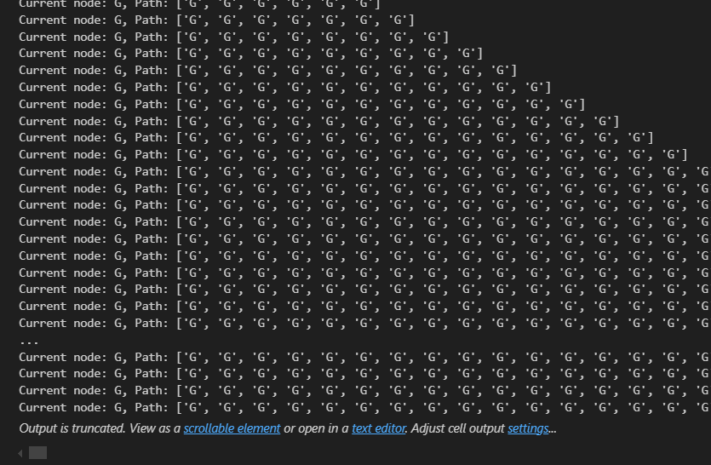

It crashed and it didn’t find a path as it was deeper in the chart

Exercise 3:

I told it to count the time it took form start point A to G

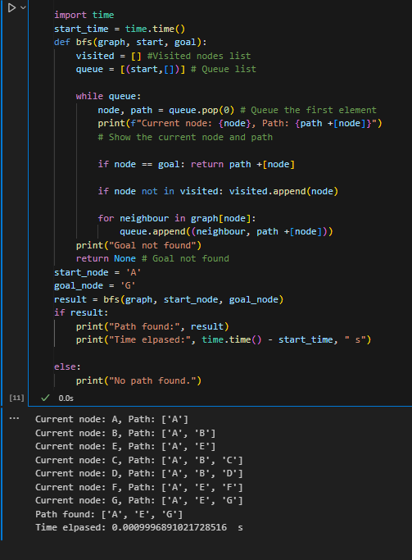

I told it to go from B to D

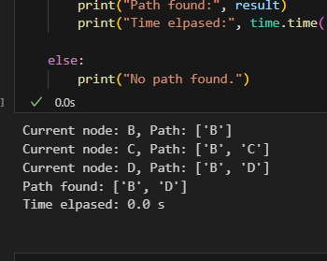

I told it to go from A to F

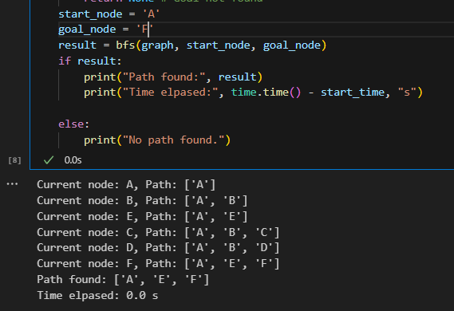

Exercise 4

Exercise 5

I told it to go from A to H

Exercise 6

It can only see up to node C for some reason?

Exercise 7

It found the path on this graph but it took the long way.

Exercise 8

I told it to start form C and go to E

I told it to start form E and go to A, and it crashed

I told it to start from C and go to H, it crashed again as it doesn’t link

Exercise 9

I managed to time both but for some reason my results were alternating for each run.

Exercise 10

This one works on graph 1 for some reason 😊

Exercise 11

Exercise 12

I told it to go from A to G for the graph in the second figure

I told it to go from A to E for the graph in the second figure

I told it to go from E to G for the graph in the first figure with a limit of 4

Exercise 13

The result depth was too large to display this was for first figure

I noticed that it repeats the dead ends till it reaches its limit

This was for the second figure I just told it to go from A to C but it kept on following the dead end from A to E

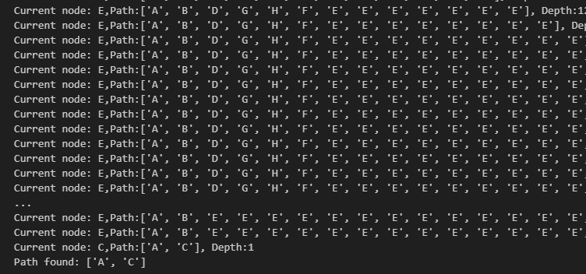

Exercise 14

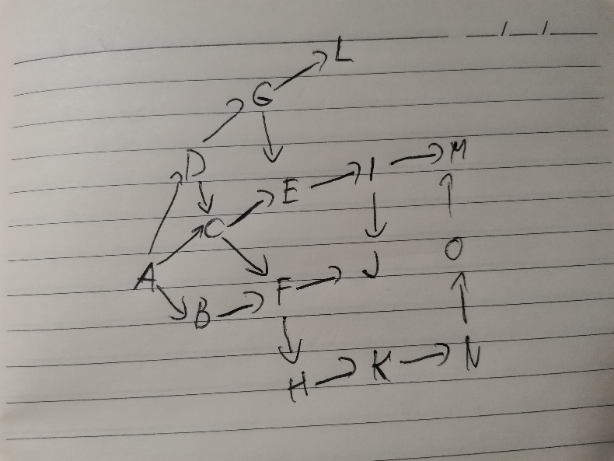

My graph with DLS

My graph with DFS – It couldn’t find it’s way

My graph with BFS

Exercise 15